SPI – Show PM2.5 Concentration on ILI9341 TFT LCD

If you are not familiar with SPI, please read [Introduction to SPI](https://www.amebaiot.com/spi-intro/) first.

Preparation

* AmebaD [ [AMB23](https://www.amebaiot.com/amebad/#rtk_amb23) / [AMB21](https://www.amebaiot.com/amebad/#rtk_amb21) / [AMB22](https://www.amebaiot.com/amebad/#rtk_amb22) / [BW16](https://www.amebaiot.com/amebad/#partner_bw16) ] x 1
* ILI9341 TFT LCD with SPI interface x 1
* PlanTower PMS3003 or PMS5003 x 1

Example

This example extends previous PM2.5 example to show the PM2.5 concentration on the LCD.

**AMB21 / AMB22 and QVGA TFT LCD Wiring Diagram:**  
(Note: PMS3003/PMS5003 sensor requires 5V voltage)

**AMB23 and QVGA TFT LCD Wiring Diagram:**

**BW16 and QVGA TFT LCD Wiring Diagram:**

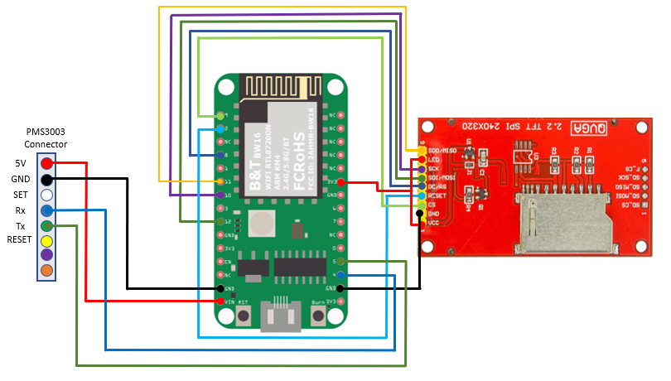

**BW16-TypeC and QVGA TFT LCD Wiring Diagram:**

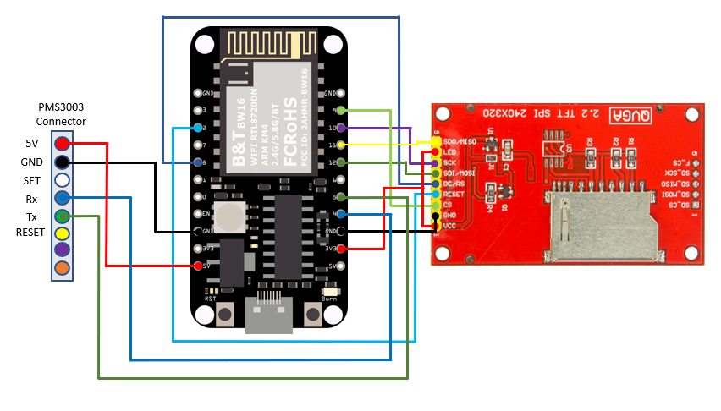

**AMB21 / AMB22 and Adafruit 2.8” TFT LCD Wiring Diagram:**

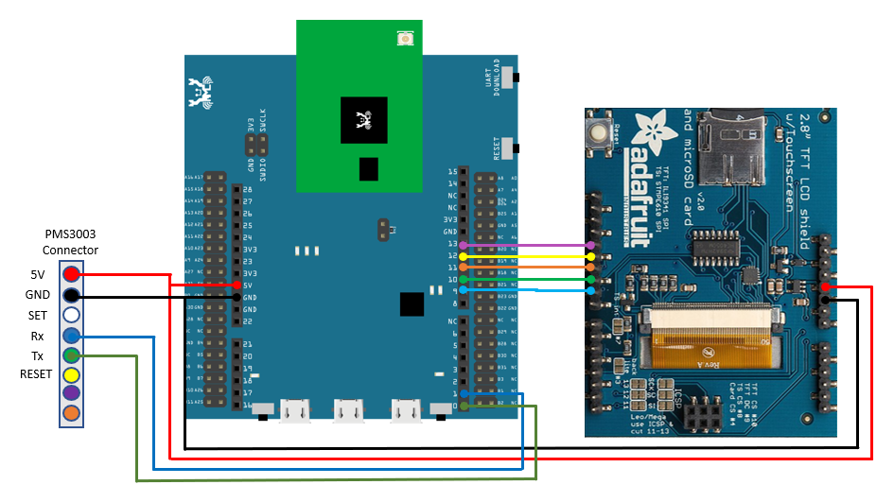

**AMB23 and Adafruit 2.8” TFT LCD Wiring Diagram:**

**BW16 and Adafruit 2.8” TFT LCD Wiring Diagram:**

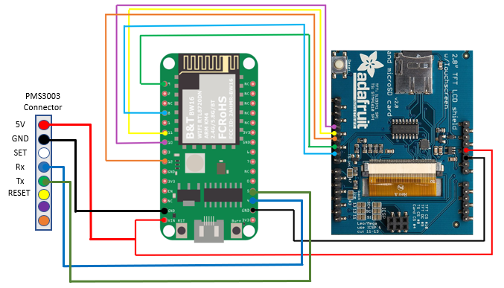

**BW16-TypeC and Adafruit 2.8” TFT LCD Wiring Diagram:**

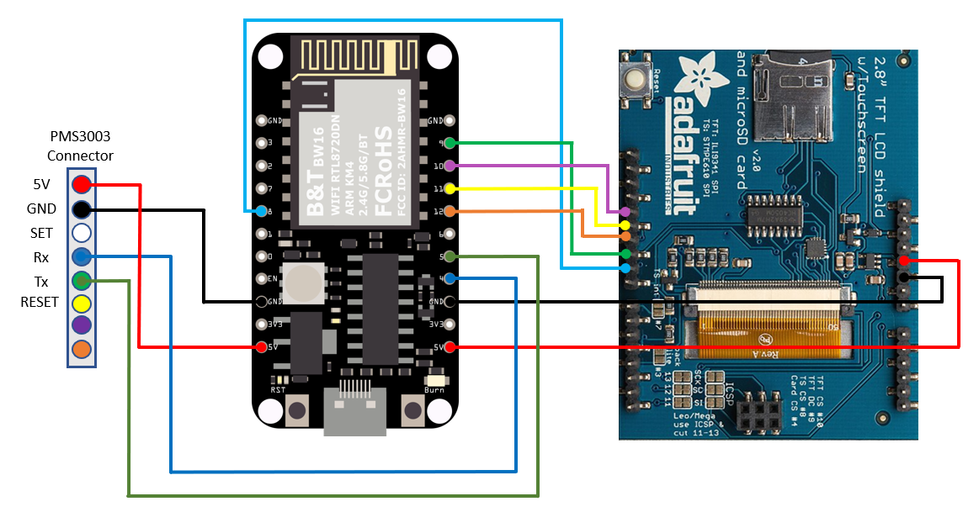

Open the example, “Files” → “Examples” → “AmebaSPI” → “ILI9341_TFT_LCD_PM2.5”

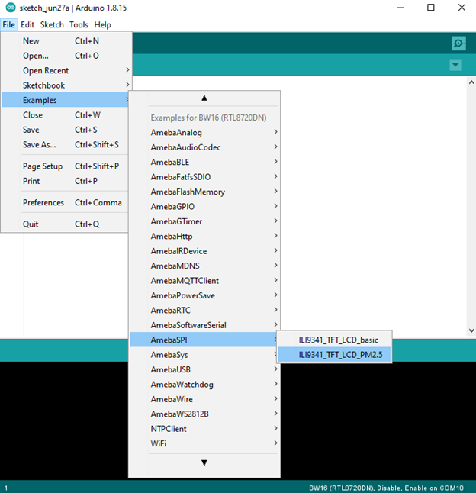

Compile and upload to Ameba, then press the reset button.

Then you can see the concentration value of PM1.0, PM2.5 and PM10 on the LCD.

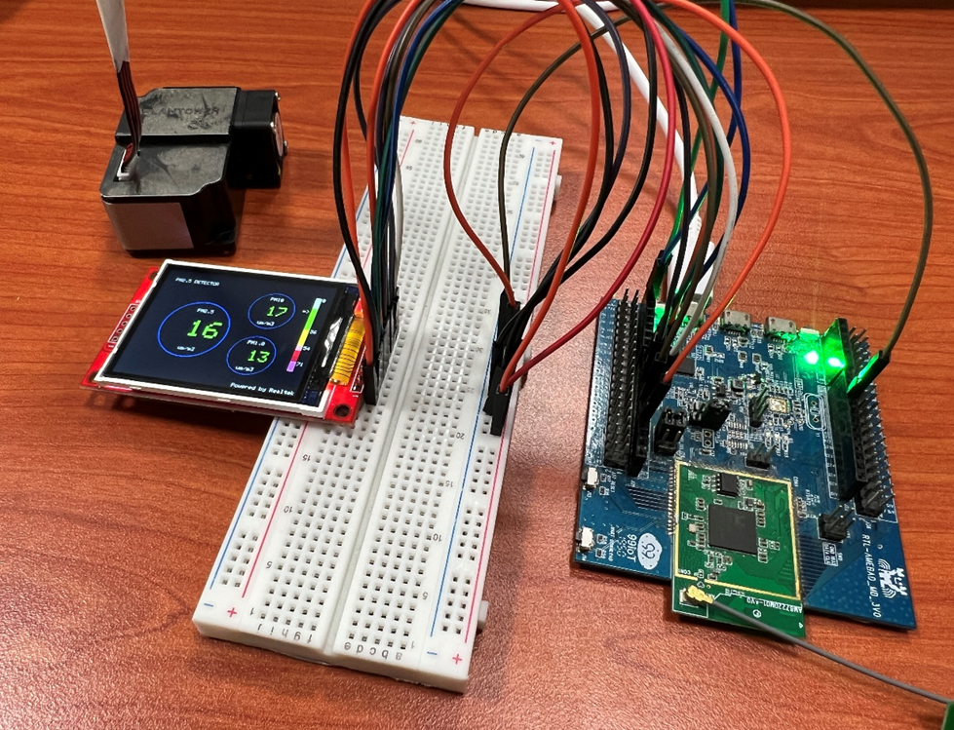

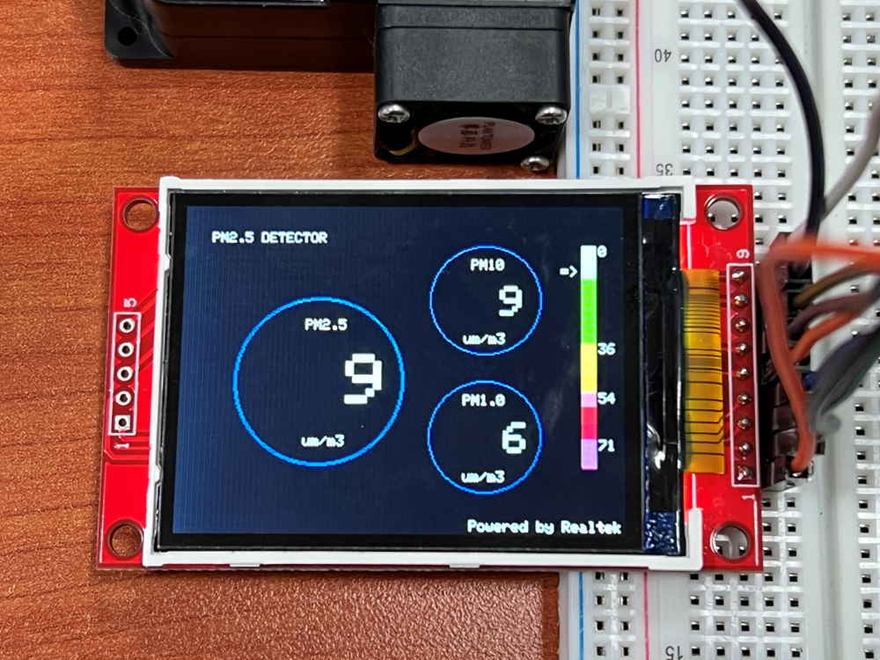

Code Reference

In this example, first rotate the screen by 90 degrees, and draw the static components such as the circles, the measuring scale, and the title text. After the concentration value is detected, it is printed inside the circle.